Design Documentation

Measuring process of LEM sensors

|  |  |  |
| --- | --- | --- |
| **Approved** | | |
|  | Name | Signature |
| ennos gmbh |  |  |
| amrosolar |  |  |

|  |  |  |
| --- | --- | --- |
| **Distribution** | | |
| Company/Department | Name | Signature |
|  |  |  |
|  |  |  |
|  |  |  |
|  |  |  |

Table of content

Measuring process of LEM sensors 1

1 History of Changes 3

2 Introduction 4

2.1 Purpose of this Document 4

2.2 Coverage of this Document 4

2.3 Terms, Definitions und Abbreviation 4

2.4 Related Documents 4

3 Global project description 6

3.1 Introduction 6

3.2 System Overview 6

# History of Changes

The changes were inscribed from the first approved version (1.0.0). Before a change is inscribed, the version number of the document has to be inscribed.

|  |  |  |  |  |
| --- | --- | --- | --- | --- |
| Number | Page / Chapter | Description | Date | Name |
| 1 |  | Version 1.0.0 prepared |  |  |
| 2 |  |  |  |  |
| 3 |  |  |  |  |
| 4 |  |  |  |  |
| 5 |  |  |  |  |
| 6 |  |  |  |  |
| 7 |  |  |  |  |
| 8 |  |  |  |  |
| 9 |  |  |  |  |
| 10 |  |  |  |  |
| 11 |  |  |  |  |
| 12 |  |  |  |  |
| 13 |  |  |  |  |
| 14 |  |  |  |  |
| 15 |  |  |  |  |
| 16 |  |  |  |  |
| 17 |  |  |  |  |
| 18 |  |  |  |  |
| 19 |  |  |  |  |
| 20 |  |  |  |  |
| 21 |  |  |  |  |
| 22 |  |  |  |  |
| 23 |  |  |  |  |
| 24 |  |  |  |  |
| 25 |  |  |  |  |
| 26 |  |  |  |  |
| 27 |  |  |  |  |
| 28 |  |  |  |  |
| 29 |  |  |  |  |
| 30 |  |  |  |  |

# Introduction

This document is a manual to show how to perform measurements for current sensors. It addresses oneself to bfh technicians who will perform future measurements.

## Terms, Definitions und Abbreviation

|  |  |
| --- | --- |
| Abbr. | Description |
|  |  |
|  |  |
|  |  |
|  |  |
|  |  |
|  |  |
|  |  |
|  |  |
|  |  |
|  |  |

## Related Documents

|  |  |  |  |
| --- | --- | --- | --- |
| Ref. Nr. | Document | Description | Author |
| - | 2014-02-21 Technical Proposal_1.4.docx | Initial proposal for LEM (not up to date in any points, as research brought new insights) | haldp2 |
|  |  |  |  |
|  |  |  |  |
|  |  |  |  |
|  |  |  |  |
|  |  |  |  |
|  |  |  |  |
|  |  |  |  |
|  |  |  |  |
|  |  |  |  |

# Global project description

## Introduction

LEM wants to test several of their current sensors in order to determine their behaviour under realistic conditions as they happen in an electric vehicle. This means that not only a constant current is applied to the sensors, but a complete current-over-time profile. One main purpose of the current sensors is the calculation of the SoC of the battery. For this, there is a small tolerance of offset current, because already small errors will accumulate to big charge differences, biasing SoC calculation. Because of this, the main output of these measurements is the Charge difference between the device under test and a reference sensor.

## System Overview

The following parts are taken from the document “2014-02-21 Technical Proposal_1.4.docx”, which described the measuring process in the first place.

R

PCMCIA

Agilent 34972A multimeter

Ethernet

CAN output

PWM output

Ethernet

Evaluator-B

Test bench

0..5V

0..600A

Temperature chamber

NI Series 2

LeCroy oscilloscope

Analogue voltage output

Laptop

with LabVIEW

HMI

DC

Analogue

current

output

USB

LIN output

NI USB-9866

Figure 1 System Overview

Basically, the system consists of one reference sensor and one or more devices under test, the Fuelcon test bench to generate the current profile and a laptop together with measurement equipment to get the results.

In order to use the Fuelcon test bench, a dummy battery has to be installed to generate the necessary minimum voltage higher than 1V. For this, a specially assembled battery block has been made, which can be reused.

If the sensor has to be tested under different temperatures, a thermal chamber can be used. In this case, the device under test is put into the temperature chamber, while the reference sensor is kept outside it. This assures that the temperature drift of the reference sensor is kept minimal.

# Setup procedure

## Introduction

This chapter proposes the necessary steps in the case that a new sensor provided by LEM will be tested. It tries to list the issues and pitfalls that occurred during the test of the first sensor (the CAB 300-C)

## Mechanical installations

### Cabling

The high current circuit is built up with several high diameter power cables. Figure 1 shows schematically the flow of the high current. Figure 2 and Figure 3 show the currently implemented installation:

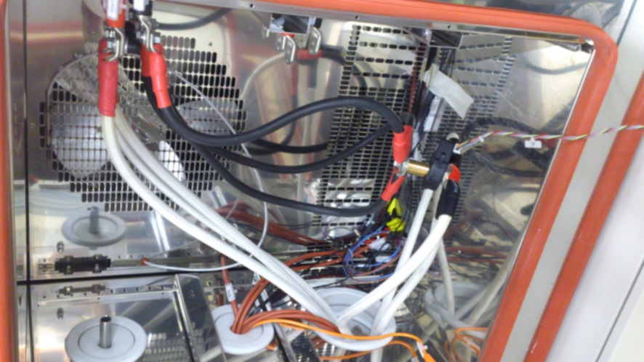

Figure 2: cabling inside temperature chamber

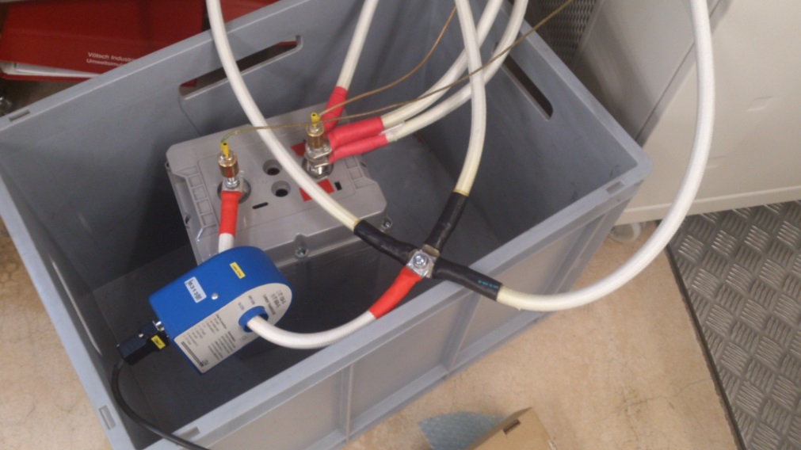

Figure 3: cabling in box outside temperature chamber

In the following, the segments of this circuits are analysed in detail:

* The three cables from the three channels are routed in parallel: 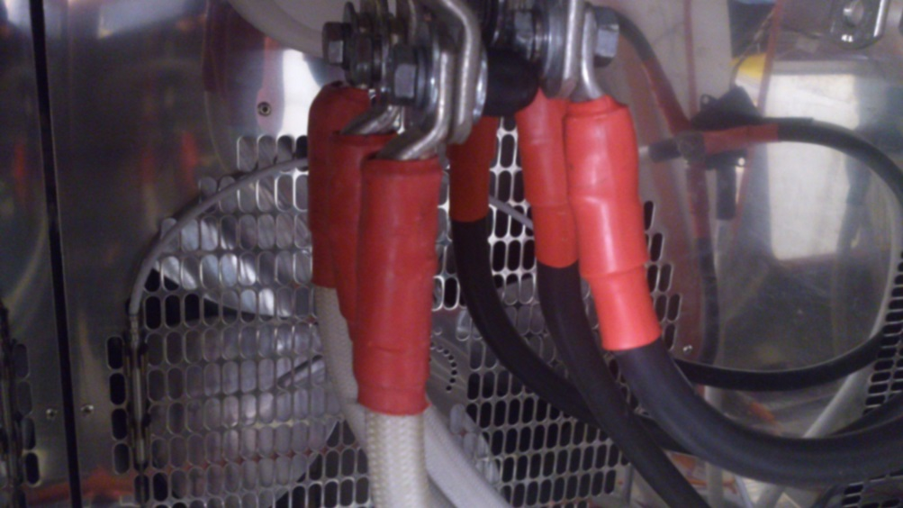

Figure 4: connection of three power cables in temperature chamber

* At the dummy battery, the cables are connected like this:   
  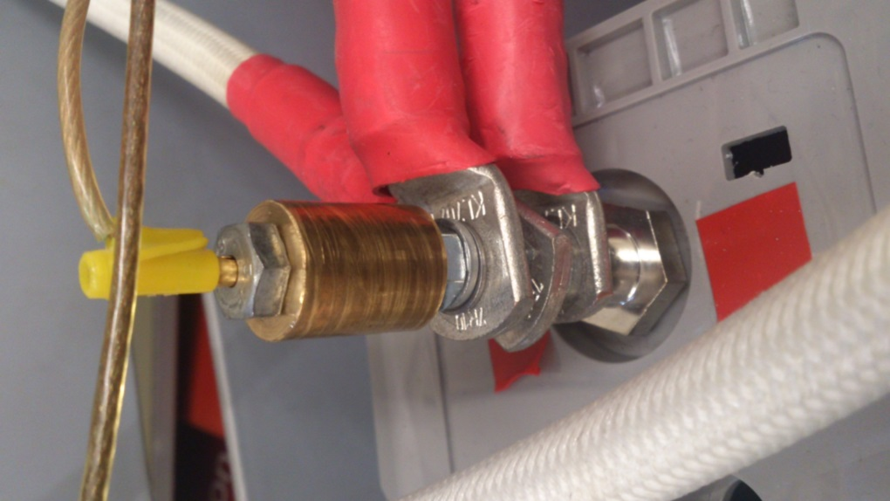  
  Between the power cable connectors, there is always one nut. This ensures an easier assembly. The bronze cylinder on the top is just to install the plugs for the cell voltage measurement for Fuelcon. It has an inner screw thread, so it can be screwed on the threaded rot on which the current plugs are mounted.
* In order to measure the cell voltage of the dummy battery with the Fuelcon test bench, there was made a simple installation which splits the cabling from the two poles to three channels each. This is because each of the three channels of the Fuelcon test bench has to measure a valid voltage in order to avoid alarm state.

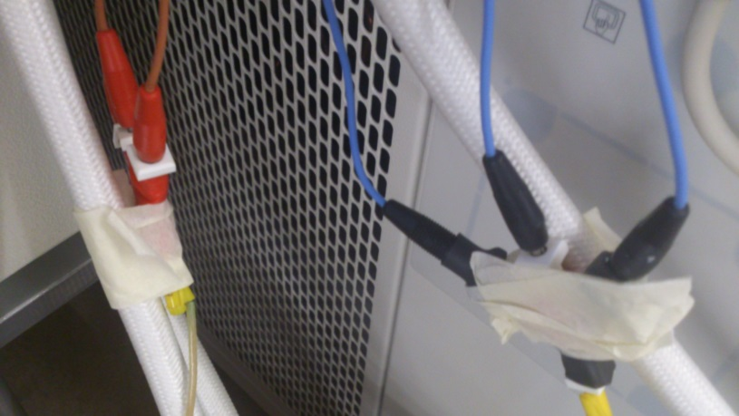

Figure 5: splitting of the battery potentials

* From the negative pole of the battery, one thick cable leads through the reference sensor: 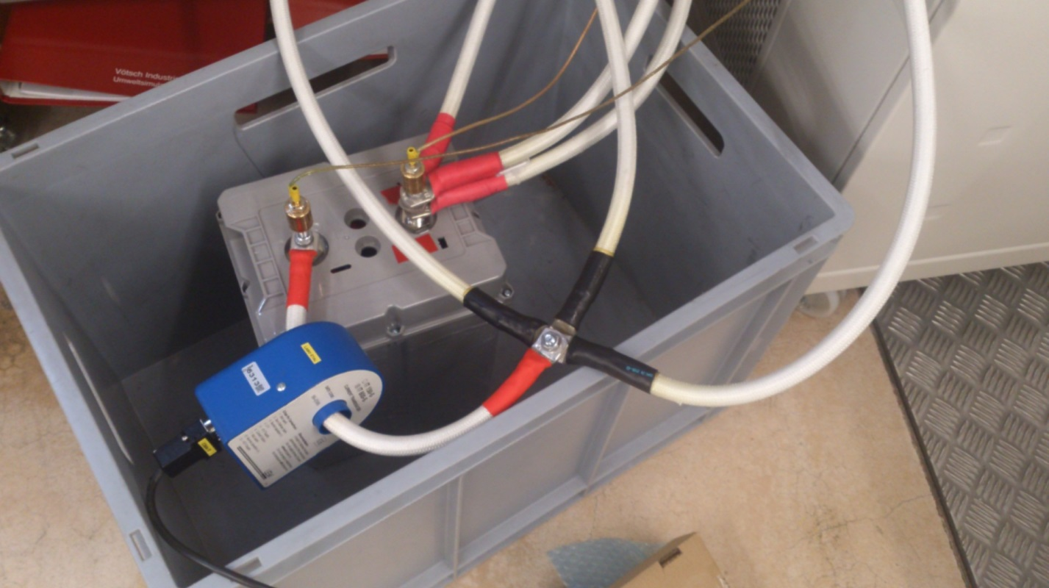

Figure 6: connection of reference sensor

The connection of the cable is similar as shown in the last point, just only with one cable.

* Then, the cable is split again in three separate cables:  
  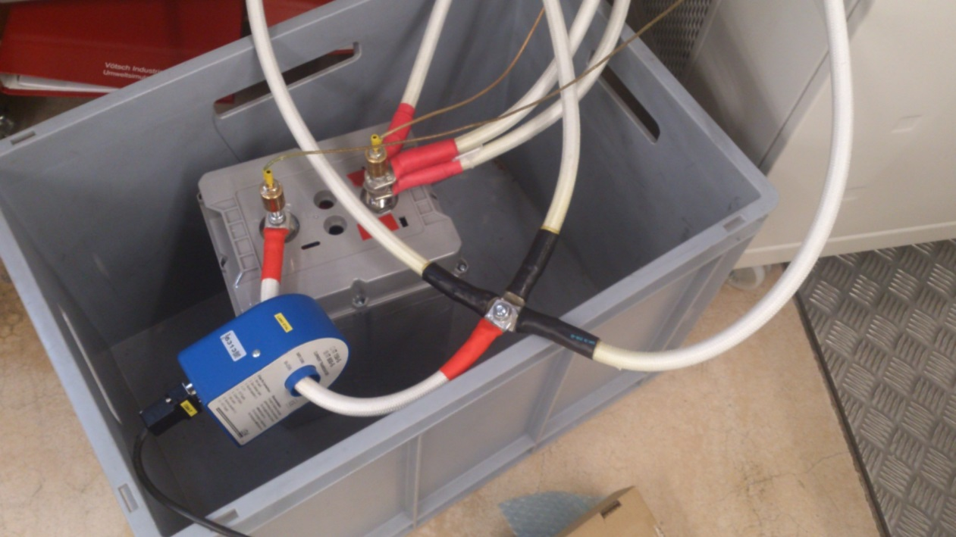

Figure 7: splitting after reference sensor

* Again, three cables are fed back into the temperature chamber, where they are connected to a cylindrical rod, which is shown in Figure 6. The assembly can be done with two M8 screws, two spring washers and two normal washers.
* From the other side of the rod, again three cables are fed to the negative pole of the fuelcon test bench. The circuit is closed.

### Install reference sensor

The reference sensor has to be mechanically installed as shown in Figure 6. Then, it can be connected via the provided DSUB-Cable with four laboratory plugs. The plugs have the following meaning:

* Red: Power supply +15V
* Yellow: Power supply GND
* Blue: Power supply -15V
* Black: Current output

The installation scheme looks like this:

Reference sensor

+15V

Power supply GND

-15V

shunt

DMM

Figure 8: installation scheme of reference sensor

The reference sensor is working like a current transformer: It measures the high current and outputs a current that is 1500 times smaller. This current is transformed into a voltage with a four point shunt. This voltage can then be measured by a sufficiently accurate voltage meter, in our case a Agilent 34972A.

### Install new sensor under test

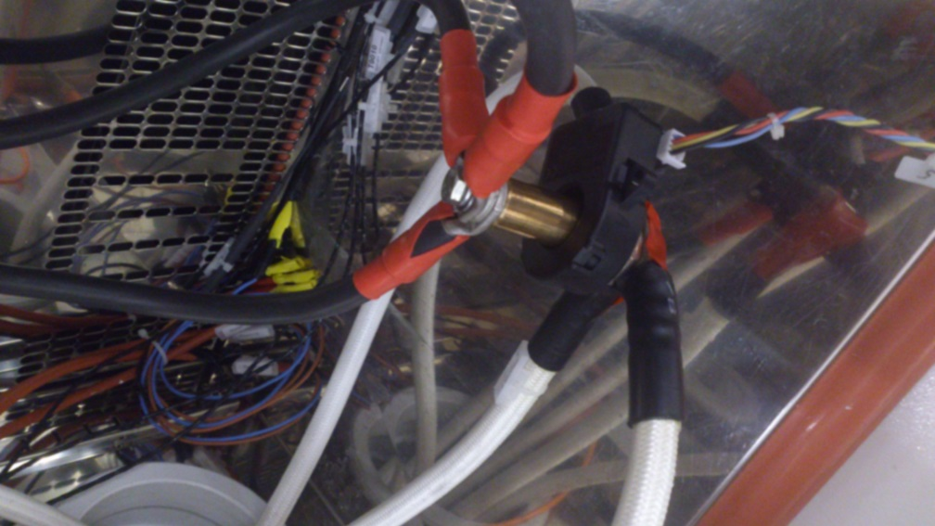

Figure 9: installation of the sensor under test

In order to deliver enough current to the sensor, a special cylindrical part was assembled, with which all three channels can be connected in parallel. This is shown in Figure 2 (bronze part). With this, up to 600A are possible. The connections can be easily removed to exchange the sensor.

If the new sensor should have a diameter smaller than 20mm or a width larger than 48mm, then another part has to be assembled.

In our case of using the CAB 300-C, a four strand wire was being used to connect the sensor with a power supply and a CAN Transceiver. The four strands of the cables have following meaning:

* Blue: Power supply + 12V
* Red: Power supply GND (Yes, this is totally illogical..)
* Yellow: CAN high
* Black: CAN low

As a power supply, a common lab supply can be used.

As CAN Transceiver, a “National Instruments CAN/HS Series 2” adapter was being used. This adapter, though having an uncommon PCMCIA interface, has the advantage of having drivers supplied in LabVIEW 2012.

## Software steps

### Generate xml file from csv file

First you need to get a .csv file containing the current values that the FuelCon test bench shall drive one after another. This .csv file must have the following form:

* The rows are separated by the semicolon (;) delimiter (not by the comma or tab)
* The first row contains the time values (in seconds). The difference between each value is constant.
* The second row contains the current values at each time (in Amps)

When a file in this form is supplied, insert it to the folder “P:\TI\fbe\ESReC\Projekte\14-001 LEM Current Sensor Measurements\software\CSV_to_sequence\CSV_in”. Note the file name of the csv file, as you have to enter it later in Matlab.

In the folder “P:\TI\fbe\ESReC\Projekte\14-001 LEM Current Sensor Measurements\software\CSV_to_sequence”, there is a Matlab file called “CSV_to_sequence_v1_1.m”. Open it and edit the following:

* In the line with “filename = 'profile.csv';“, replace „profile.csv“ by the name of your csv file.
* The script offers a function to average several current values of the csv file into one current value for the test bench. This can be useful if the time step defined in the file is smaller than the one possible for fuelcon (500ms TODO). For example, if you define a timestep of 1.0s, and in the file, every 50ms the current is updated, then there are always 20 values averaged into one output value. In order to change this, got to the line ”timestep = 0.5;“, and replace 0.5 by the desired value in seconds.

When these settings are performed, execute the script with F5. Matlab may ask you if you want to change the current folder. Accept this. The script then converts the currents from the csv file into one or several xml files for the Fuelcon sequencer. The division into several xml files is necessary because the sequencer has a limited storage size. This is beginning to become relevant at 2000 points or more.

When the conversion is complete (may take a moment), the message “'Konvertierung abgeschlossen!“ is displayed and you can get the converted files. These are to be found in the folder „P:\TI\fbe\ESReC\Projekte\14-001 LEM Current Sensor Measurements\software\CSV_to_sequence\sequence_out“. Copy all files in this folder onto the computer which controls the fuelcon test bench. There, put the files in the folder „D:\FuelWork\Sequences\sequence_out\“. Then it will be recognised by the FuelCon script.

### New LabVIEW code for sensor under test

If there is a new sensor implemented, it has to be fed into the existing LabVIEW structure. For this, at several points, adaptions have to be made.

Let’s assume we want to add a new sensor with analogue voltage output called “LQ-120”. First, go to the folder where the LabVIEW programme is located: “P:\TI\fbe\ESReC\Projekte\14-001 LEM Current Sensor Measurements\software\LabVIEW\Current sensor tests”. Then, open the file “SensorTypes.ctl”. There, add a new enum element at the end called “LQ-120”. Your enum should look like this afterwards:

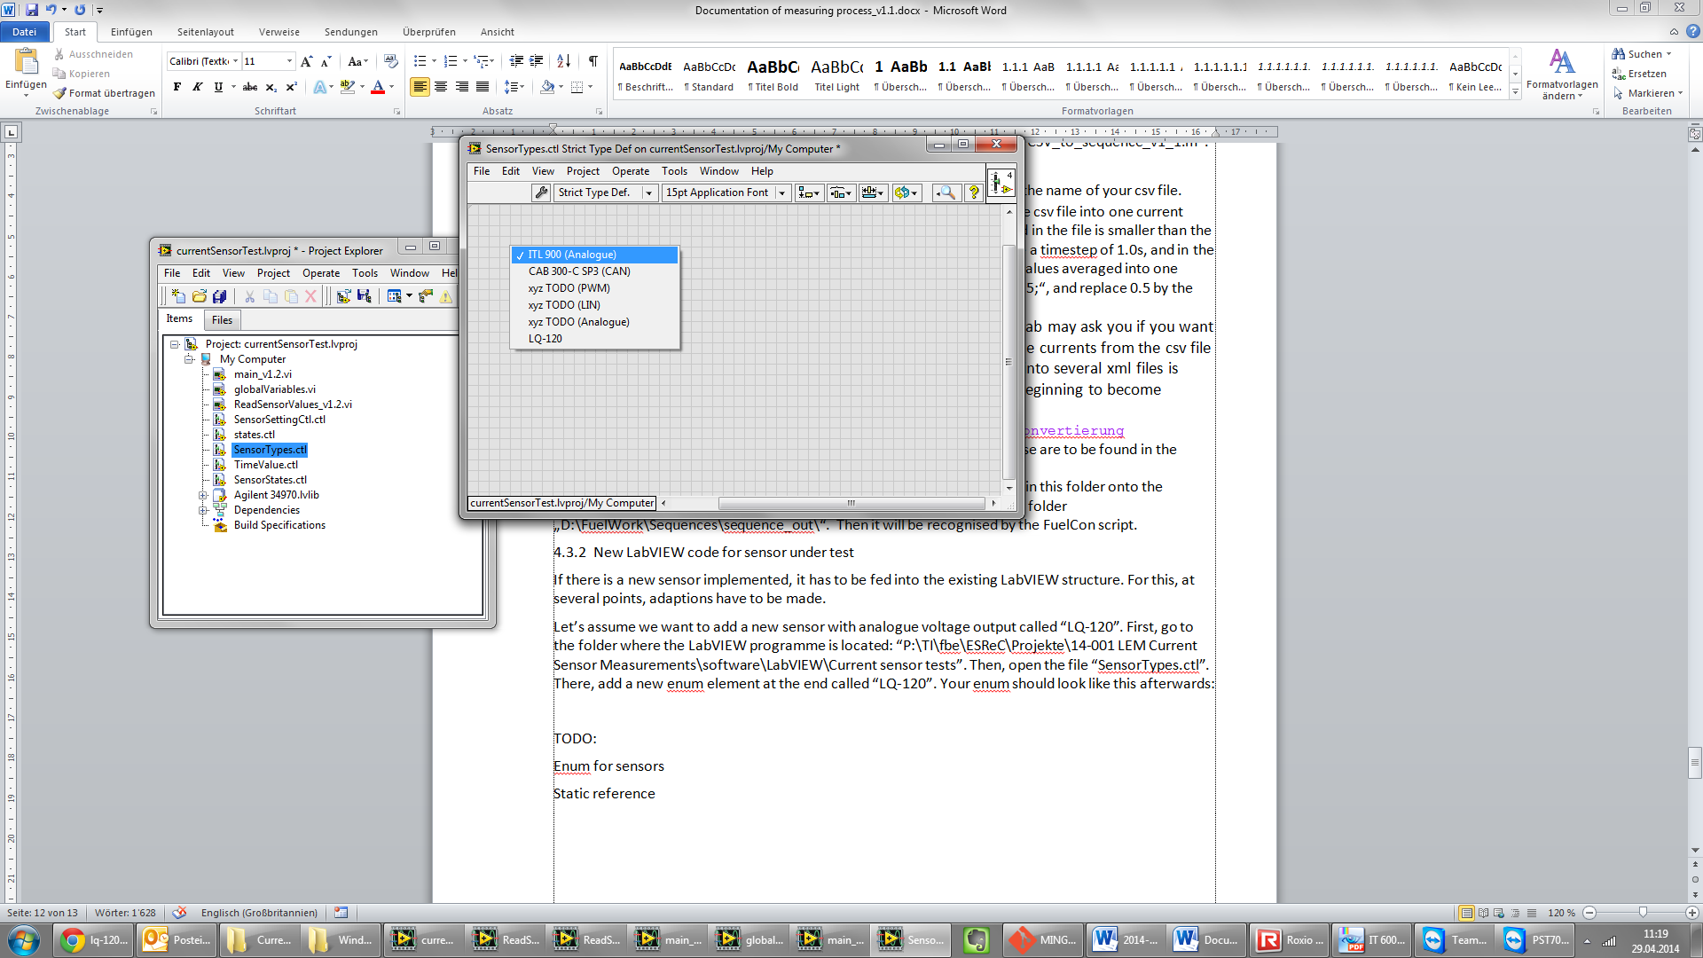

Save and close the file.

Then, we want to implement the new sensor to our main VI. 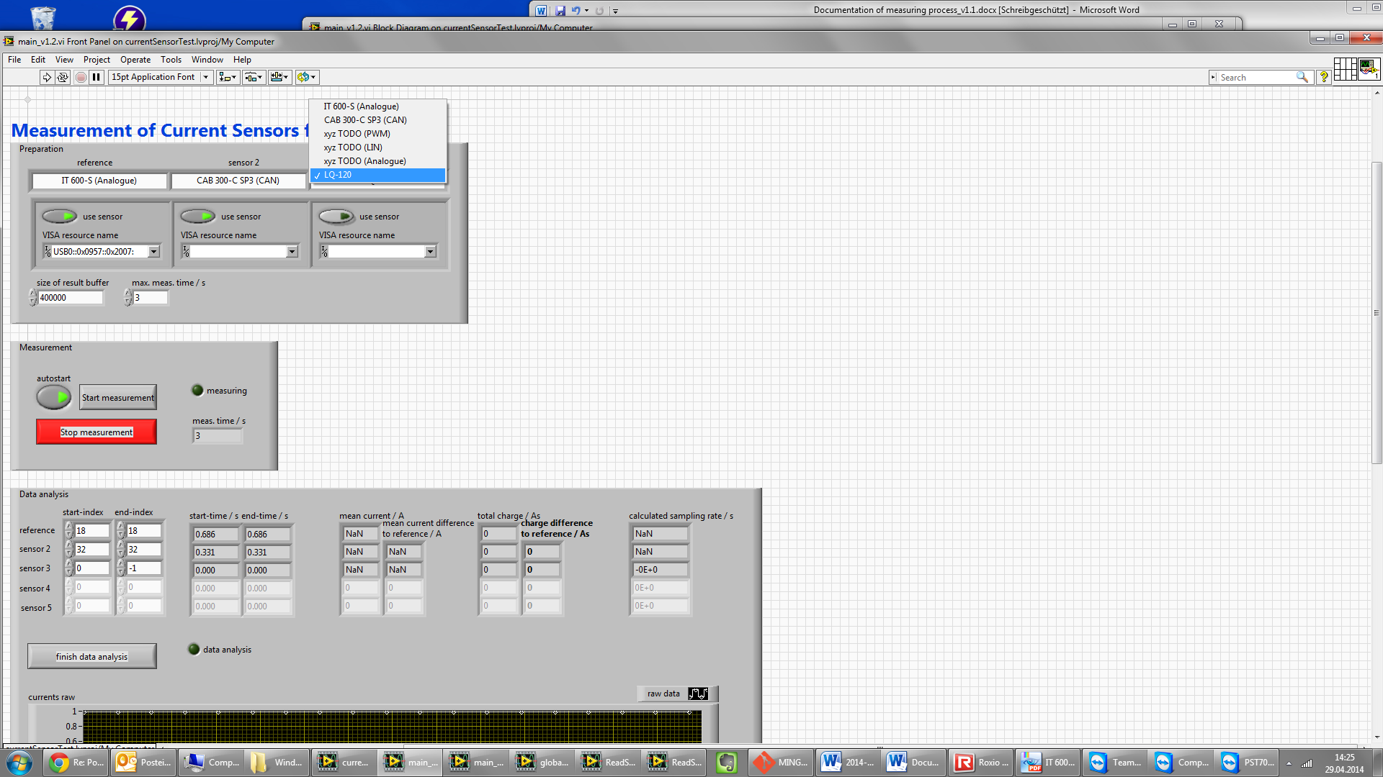

For that, select a free sensor slot (in this case the third slot) and select the new sensor in the dropdown menu.

Next, you have to implement this sensor inside the “ReadSensorValues_v1.2” VI. This VI is built as a state machine, with the states

* init
* measure
* terminate

In each of these states, there is a case structure which differs between the sensors. In order to implement the new sensor, right click on a case structure and select “Add Case for Every Value”. With this, an empty case is created for the new sensor.

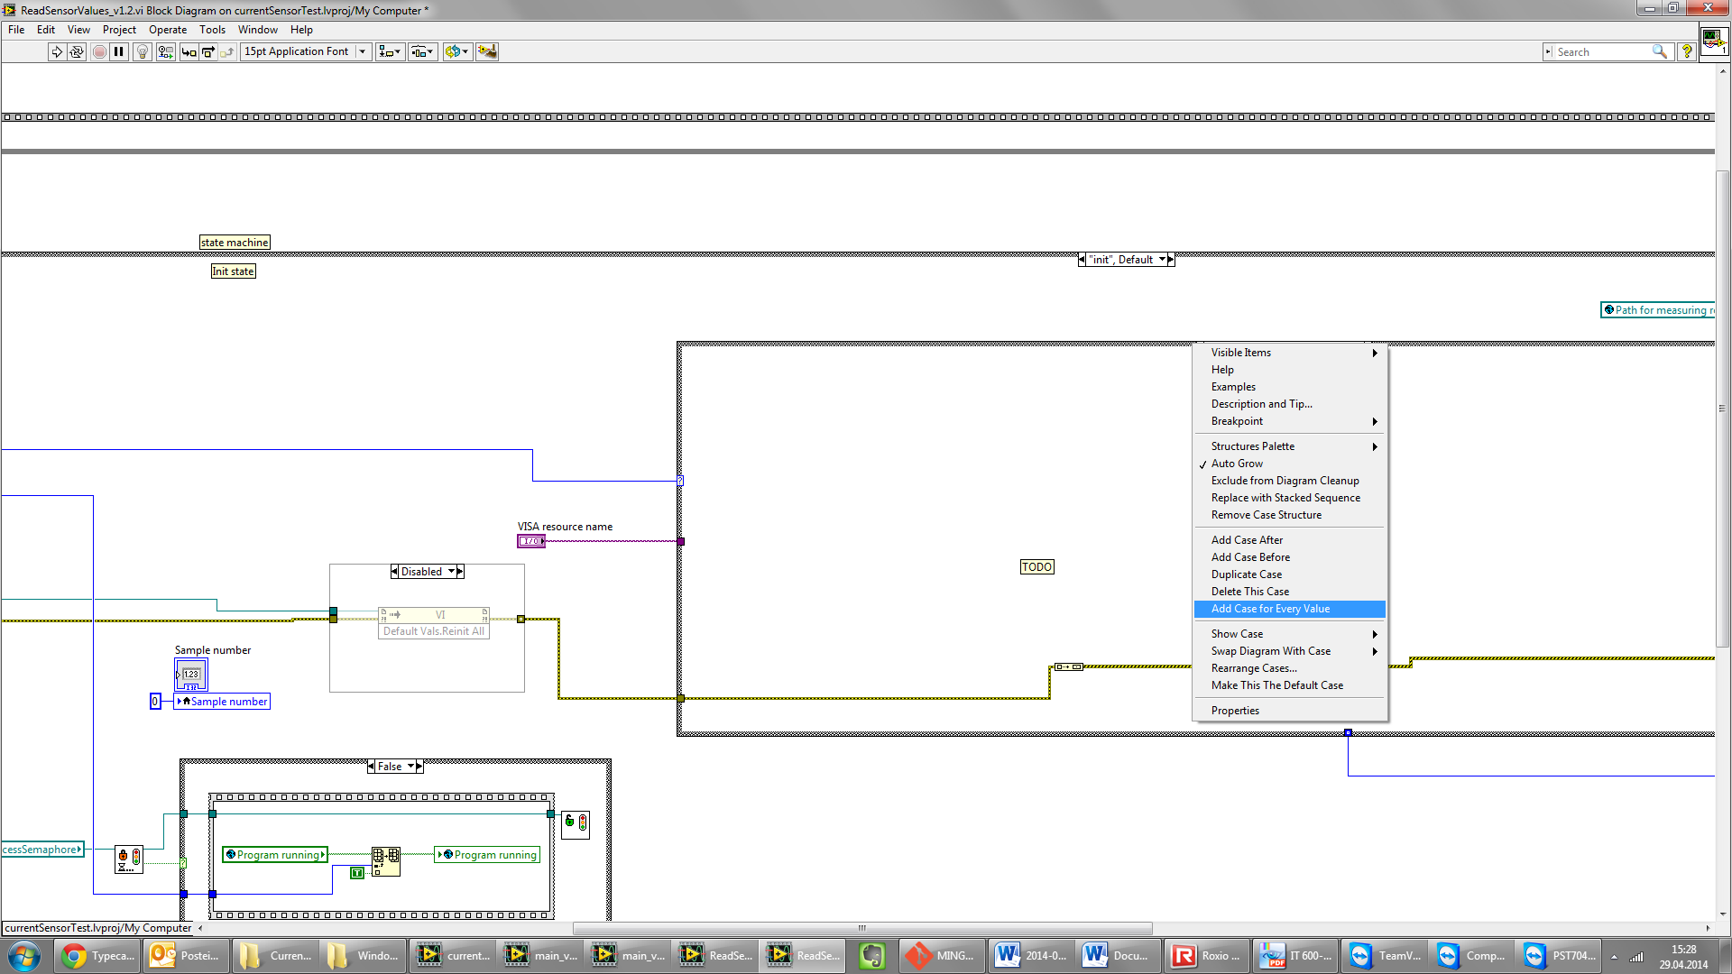

After you made this for all three states, you can fill them with function:

* The init state has of course to initialize the sensor. Besides, it has to provide the name for the csv logger VI.
* The measure state has to write all new data to the arrays “NewestValues” and “AllValuesOfSensor”. The “NewestValues” is a global array which contains one measurement point of all sensors. This serves as an overview over all current measurements. The local array “AllValuesOfSensor” contains all measured values until that time, but only of the current sensor. In the terminate state, it will be copied to the global array “AllValues”. This two-step procedure is performed due to speed reasons.
* The terminate state is used to free the resources of the sensor.

For more information on how to implement this functionality, please have a look at the existing sensors.

### Testworks adaptations

## Documentation

### Standards used in the first measurement